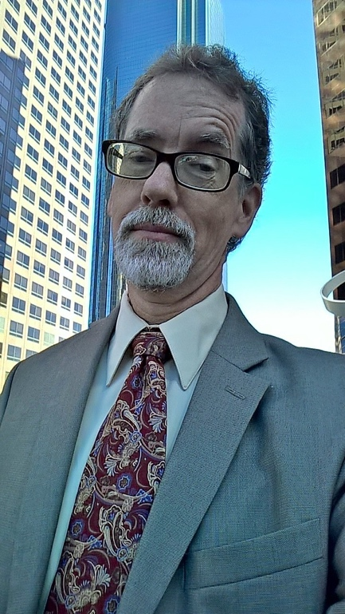

Barry Waite worked for the City of Carson 29 years where he served as Business Development Manager after having served several years as the city’s Geographic Information Systems Administrator. He also worked in the city manager’s office and as a city planner. In fact, he worked for every department in the city except recreation, although he did teach ceramics for the LA County Probation Department many years ago. Close enough. He now consults in the fields of economic development and GIS and since 2007 has been an instructor with the USC Price School of Public Policy. His particular area of interest is the geographic analysis of demographics and consumer spending.
He has a master’s degree in public administration from USC and a GIS certificate from Cal State Long Beach. He is a former city council member for the city of Lomita. He has taught a number of courses in the GIS certificate program at CSULB. He is the co-author of “The GIS Guide for Local Government,” published by the International City and County Management Association.
Barry serves on various public boards and commissions. For fun, he is a barbershop harmony singer and is a regular performer of stand-up comedy at the Comedy Store, inspired by his years of public service.

