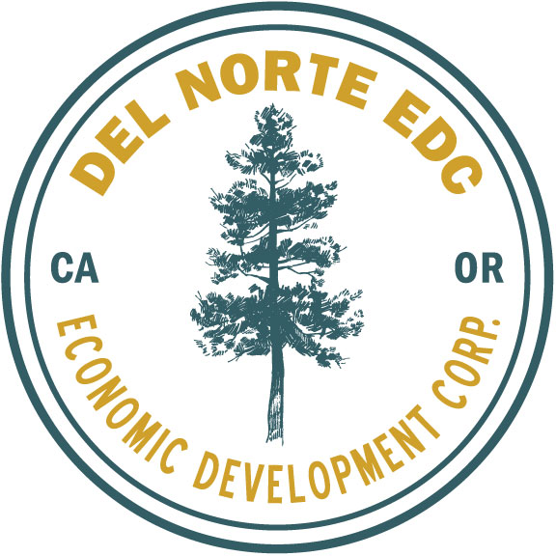
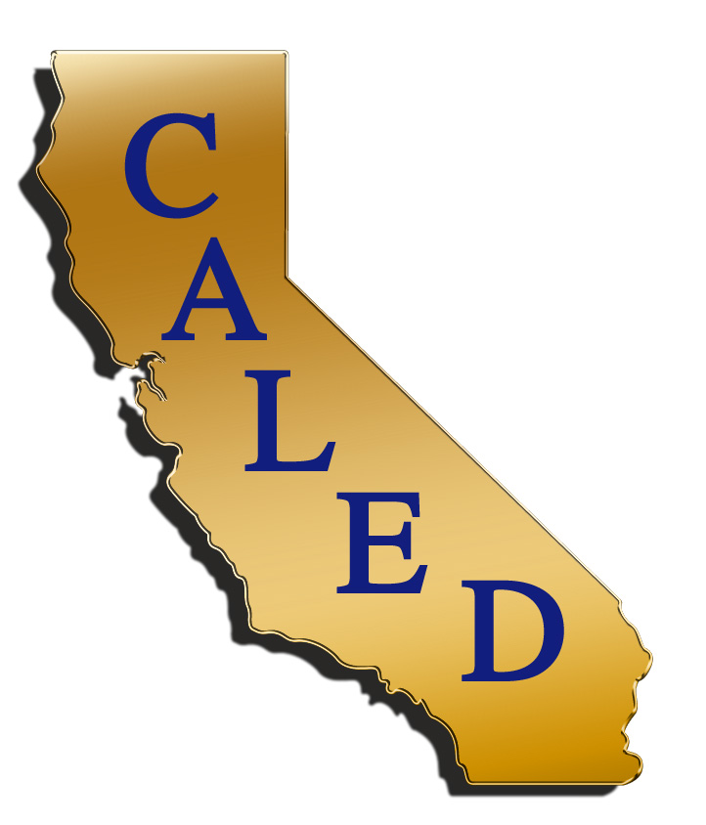

Bi-County Economic Development Stakeholders Meeting Agenda
August 24, 2018
Tolowa Event Center located at the Lucky 7 Casino
350 N Indian Rd., Smith River CA 95567

- Check-in & Networking 8:00 AM
- Opening and introductions- Roxann Haynes, DNEDC 9:00 AM
- Keynote Speaker Gurbax Sahota, CALED CEO 9:15 AM
- Needs Assessment Group 9:45 AM
- Lunch 11:00 AM
- Discussion of Assessment Group
& Brainstorming Session 11:30 AM
- Closing 1:00 PM

